**ASSIGNMENT (INDIVIDUAL)**  SUBMISSION ON FRIDAY

QN1. Write an html page without css. The page must have 3 links Home, about us and contact us in the navigation bar. on the home page display lorem ipsum text, on the about us populate it with lorem ipsum, and finally on the contact us put on the list.

QN2. design an html page with 5 pages Home, list, form, table, radio button. On the homepage put lorem ipsum, on list put on a list of any ten items, on form put on a form of student object, on table put on the table of student object data members for radio button put anything with radio button.

**ASSIGNMENT(GROUP)** SUBMISSION ON MONDAY

QN. Write html code that mimic this webpage. The contents are videos and their captions. The one on the right side are videos as link and caption.

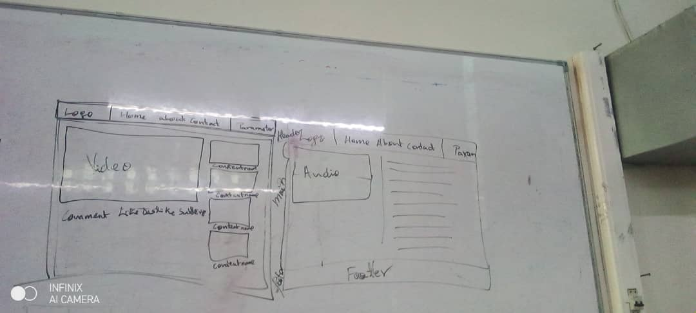

Good Luck!!!